**Room Management System**

**Ogwang Treva Antony**

**111059**

**An Information System Project Proposal submitted to the Strathmore Institute of Management and Technology in partial fulfilment of the requirements for the award of the Diploma in Business Information Technology of Strathmore University**

**Strathmore Institute of Management and Technology**

**Strathmore University**

**Nairobi, Kenya**

**June 2019**

Declaration and Approval

I declare that this work has not been previously submitted and approved for the award of a diploma by this or any other University. To the best of my knowledge and belief, the research proposal contains no material previously published or written by another person except where due reference is made in the research proposal itself.

Student’s Signature:

………………………………………… Name

………………………………………… Signature

………………………………………… Date

**Approval**

Supervisor’s Title and Name:

………………………………………… Signature

………………………………………… Date

Abstract

In many institutions of higher education, space is a precious commodity and its correct utilization directly affects the functioning of the working environment, and its results. In academic institutions, there are continuous changes in rooms that have a direct impact on the space distribution.

Students face a challenge when trying to locate a vacant room within the institution. Lecturers too encounter difficulties in the process of planning for a lecture make-up session. This is due to the presence of many rooms and the absence of a general timetable that would allow them to monitor the occupation of different rooms. Therefore, improving the existing distribution and utilization of the existing rooms in particular is very important, to ensure the daily obligations are effectively met with minimal distractions possible. Regarding the study on the concerns of maximizing the possible ways of using existing room space in Universities and blending it with appropriate time to determine its allocation. This is a web application to automate this tiresome and time-consuming process of having to manually search for unoccupied rooms available in academic institutions. It allow registered users to be able to view and relocate to any vacant room in the institution accessible to them during their free time. Any authorized changes to the platform is visible to every registered user.

Lecturers can also book rooms for example when they want to organize a make-up class, which is part of the timetable so that every user can view it until the administrator removes it from the system. Waterfall methodology is adopted when developing this system. It is the most suitable methodology because it makes sure that you complete every phase before moving to the next making you to develop a good system. The system is coded using Notepad ++ because it uses php language because it allows one to develop a web application.

**Table of Contents**

Declaration and Approval ii

Abstract iii

Table of Contents iv

List of Figures vii

Chapter 1: Introduction 1

1.1 Background of Study 1

1.2 Problem statement 2

1.3 General Objectives 2

1.4 Specific Objectives 2

1.5 Justification 3

1.6 Scope and Limitations. 3

Chapter 2: Literature Review 4

2.1 Introduction 4

2.2 Challenges faced by Previous Systems 4

2.3 Related Works 4

2.3.1 Classroom booking 4

2.3.2 Hong Kong Module 4

2.3.3 Class Alignment Problem System 5

2.3.4 Visual Class Scheduler 5

2.4 Conclusion 5

2.5 Conceptual framework 6

Chapter 3: Methodology 7

3.1 Introduction 7

3.2 System Development Methodology 7

3.3 Requirement Analysis 8

3.3.1 Functional Requirements 8

3.3.2 Non-Functional Requirements 8

3.4 Tools and techniques to be used 9

3.4.1 My Structured Query Language. 9

3.4.2 PHP My Admin. 9

3.4.3 Notepad ++ 9

3.5 Deliverables 9

3.5.1 Administrator Module 9

3.5.2 User Module. 9

Chapter 4: System Analysis and Design 10

4.1 Introduction 10

4.2 Analysis Diagrams 10

4.2.1 Use case diagram 10

4.2.2 Sequence diagram 11

4.2.3 Context diagram 11

4.2.4 Level 0 diagram 12

4.2.5 Entity Relationship diagram 13

4.2.6 Database schema 14

4.2.7 Flow chart 15

Chapter 5: System Implementation and Testing 16

5.1 Introduction 16

5.2 Administrator module 16

5.3 User module 19

5.3.1 Lecturer 19

5.3.2 Student 22

5.4 System testing 24

Chapter 6: Conclusion, Recommendations and Future works. 25

6.1 Introduction 25

6.2 Conclusions 25

6.3 Recommendations 25

6.4 Future Works 25

References 26

Gantt chart 27

List of Figures

Figure 2.1 Hong Kong Module 5

Figure 2.2 Conceptual framework 6

Figure 4.1 Use case 10

Figure 4.2 System Sequence 11

Figure 4.3 Context diagram 12

Figure 4.4 Level 0 diagram 13

Figure 4.5 Entity Relationship diagram 14

Figure 4.6 Database schema 14

Figure 4.7 Flow chart 15

Figure 5.1 Admin log in 16

Figure 5.2 Room details 17

Figure 5.3 Update room details 17

Figure 5.4 Room booking details 18

Figure 5.5 Users registered 18

Figure 5.6 Lecturer registration 19

Figure 5.7 Lecturer log in 20

Figure 5.8 Lecturer book room 20

Figure 5.9 Success message 21

Figure 5.10 Booking history 21

Figure 5.11 Student registration 22

Figure 5.12 Student log in 22

Figure 5.13 Student view free room 23

Figure 5.14 Student user profile 23

Figure 5.15 System Testing 24

Figure 6.1 Gantt chart 27

# Introduction

## Background of Study

In Kenya, there are different systems of education that determine the qualification of students to proceed to higher learning institutions to attain advanced education (T M. , 2000). Students from different schools congregate here in large numbers, hence the presence of numerous classrooms that pose a challenge to the management of activities that happen there. Some of these activities include Continuous Assessment Tests, lectures, laboratory exercises and examinations.

The issue of managing already existing resources has been a challenge in many different fields in the world (M, 2015). The major factor that is important in order to solve this problem is the type of system to use. Thus, since resources (rooms) are limited, it must be well managed by the institution towards availability and suitability with the students and lecturers.

The ideal space utilization and the fulfillment of extra necessities or conditions is very important. In this, a condition exists: the capacity of the classrooms and the space required by the courses and their timings cannot be modified, because the system is reflecting an already existing schedule. A better solution for this room utilization problem is one where students and lecturers have an easy access to the institutions complete daily schedule on their smartphones.

## Problem statement

In many higher learning institutions, students face a hard time when trying to locate a vacant room to carry out their individual activities like studies and research (T M. , 2000). Lecturers also encounter challenging situations in the cases of classes’ collision, due to an unsynchronized timetable. In the cases of lecturers organizing for a make-up class session, they have to go through a tiresome process in search for a suitable time in future. Locating a vacant room is difficult because of the large number of rooms and the absence of an overall schedule for one to determine a vacant room (S, 2016). All these lead to wastage of a lot of time, ineffective plans made by both students and lecturers, and overall inconveniences to both parties.

This is solved by availing an easily accessible timetable that is well synchronized, to both students and lecturers on a digital platform. This enables them to have a simplified view of the day’s schedule that will make decision making simple. Lecturers are able to book a vacant room for future use, while students can access a vacant room within the relevant time.

## General Objectives

To save time wasted by both students and lecturers in higher learning institutions, by developing an android application that avails the daily schedule of an institution that makes it easy for vacant rooms to be identified.



## Specific Objectives

1. To investigate on existing timetabling systems.
2. To analyze problems faced by existing timetabling systems.
3. To design a timetabling systems for higher institutions.
4. To develop a timetabling system for higher institutions.
5. To tests and validate the system.

## Justification

The Room Management System avails the latest schedule to students and lecturers on a mobile platform, making the activities around the university curriculum more transparent and swift. With the help of this system, lecturers are able to determine a room that they would like to occupy for their makeup sessions. Student are also able to search for free rooms so that they can study or have group discussions. This is reflected in the system.

## Scope and Limitations.

The field of operation of this system concerns the current and future vacancy of all rooms, and the capability of booking a certain room in advance.

This system does not allow the clashing of lecture sessions belonging to a particular lecturer, according to their timetable. The system is only used by institutions with access to the internet, and can only be accessible to people with an access to a smartphone.

# 

# Literature Review



## Introduction



This chapter looks into the ways in which mobile technology has changed the way people prefer using mobile applications rather than mobile websites though mobile websites though most websites are formatted only for a web designed look when browsing via phone. It does not seek to review any online system used for both the students and lecturers in the institution.

## Challenges faced by Previous Systems

Some of the challenges the previous systems faced are like:

The previous systems did not include a synchronized database that lead to misleading contents to the users. This can be solved by availing a well-synchronized database. The previous systems also lacked a user-friendly user interface, where students faced a hard time trying to locate a specific vacant room in the system and lecturers did not have the ability to book vacant rooms over the interface. Previous systems lacked a date and time integrated system that only showed the time bracket of a particular vacant session.

(T M. , 2000)Encountered the problem of resource determination whereby he did not get the appropriate data he required for his system. This was also encountered by previous systems that were forced to contain incomplete information in their systems.

## Related Works

In the previous years some systems were developed to perform a similar work of managing rooms in higher learning institutions. They include:



### Classroom booking

Classroom bookings is a tool designed to be used by the faculty every teacher logs in to the system and updates their availability schedule. The classes are scheduled and corresponding classrooms are assigned to them. (S, 2016).

### Hong Kong Module

Hong Kong University uses the system whereby they have integrated it with their school application whereby only a registered student logs in with his credentials and checks whether there is a vacant room.

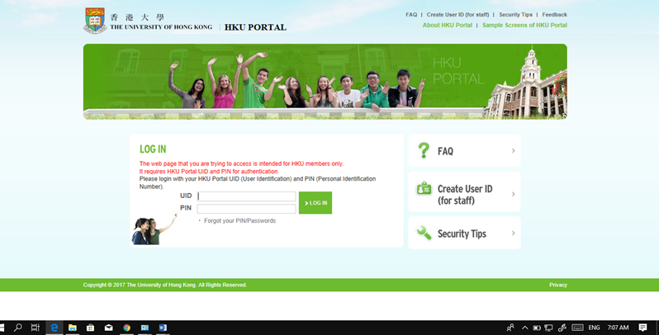

Figure 2.1 Hong Kong Module

### Class Alignment Problem System

When looking speciﬁcally to CAP one of the most relevant and cited paper is written by Carter and Tobey [1992] and discusses, as its title indicates, the complexity of the Classroom Assignment Problem in diﬀerent circumstances. Their focus is on the kind of cases that schedulers might encounter in practice and explains why room assignment is sometimes easy and sometimes immensely diﬃcult. Note that computationally easy problems will still take weeks or even months when solved by hand.

### Visual Class Scheduler

This is a paid and costly application. It also comes with several additional and unwanted features. The main drawback of this application lies in the fact that this was designed to be used by a small school setup and not for a university with more than 1000 classes needed to be scheduled (S, 2016)

## Conclusion

Resources and time is a big challenge faced by the previous system developers. The gaps identified are consideration of all the schools and faculties in a particular. For this system, it is able to store the schedule of the rooms and update them as soon as the administrator alters them.

## Conceptual framework

This system has two modules; Lecturer module and Students module. The lecturer has a privilege to book a room for a specific exercise such as a makeup class unlike a student who only has the chance to see an empty room when he /she is needs one.

In the case of an intended make-up session by the lecturer, a booking option is only be available to the lecturer, for a vacant room. Therefore, the room is indicated as booked to all users.

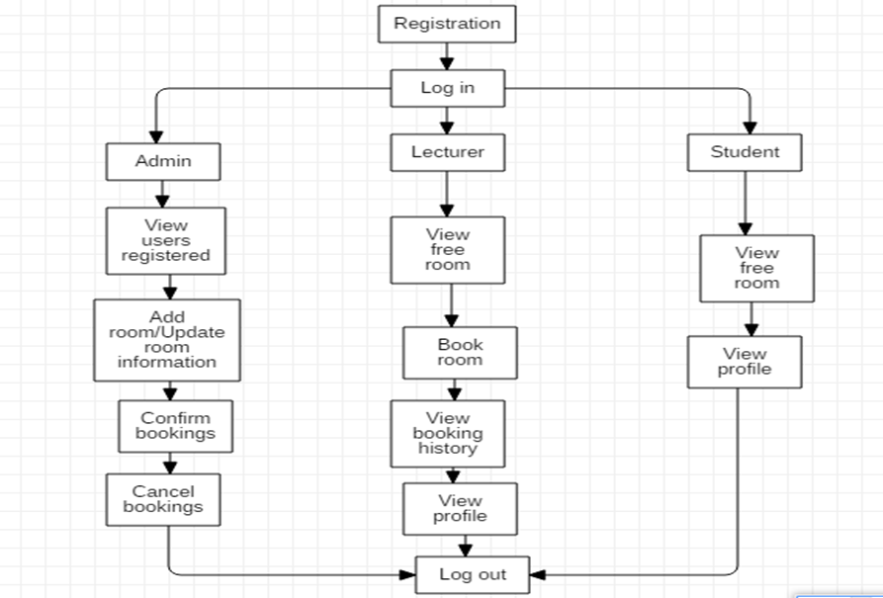

Figure . Conceptual framework

# Methodology



## Introduction

This section identifies the methodology that is used in the different phases when developing this system. It also provides the requirements that users are be able to do when accessing the website. The tools and techniques used in developing the system are also highlighted in this chapter. Finally, the chapter also houses the deliverables

## System Development Methodology

Waterfall methodology is the most suitable methodology to use because it assists systematically to finish every phase before proceeding to the next phase. It gives emphasis of completion of one phase before moving to the next phase. It also helps in planning and testing, modifying and upgrading your system according to your desired needs. Below are the phases;

1. **Requirements**

It involves understanding what needs to design and what is its function, purpose, etc. Here, the specifications of the input and output or the final product are studied and marked. In this phase all the requirement for the system were studied accordingly.

1. **System design**

The requirement specifications are studied in this phase and system design is prepared. System Design helps in specifying hardware and system requirements and helps in defining overall system architecture. In this phase the system was designed so as to get a perfect system. All the changes and modification were done in this phase.

1. **Implementation.**

With inputs from system design, the system is first developed into a program, which is integrated into the next phase. The program is developed and tested for its functionality, which is referred to as Unit Testing. In this phase the designed system wass developed into a fully functioning system.

1. **Integration and Testing.**

The program developed in the implementation phase is integrated into a system after testing. The software designed, needs to go through constant software testing to find out if there are any flaw or errors. Testing is done so that the client does not face any problem during the installation of the software. In this phase any changes or errors arising in the system were dealt with accordingly.

1. **Deployment of System.**

Once the functional and non-functional testing is done, the product is deployed in the customer environment or released into the market.

1. **Testing.**

This step occurs after installation, and involves making modifications to the system or an individual component to alter attributes or improve performance. These modifications arise due to either change requests initiated by the customer, or defects uncovered during live use of the system. The client was provided with regular maintenance and support for the developed software.

## Requirement Analysis



### Functional Requirements

#### Registration.

A new user registers and creates an account with the system so that he/she can be able to access and utilize the services offered by the website. One is needed to provide his/her full name, choose a username and create a strong password.

#### Log in.

An existing user to logs in whenever he/she wants to access the website information offered by the application. This increases security so that the website cannot be tampered with.



#### Forgot Password.

If a user by any chance forgets his/her password he/she needs to submit his/her email for verification that he/she is an existing user so that the password can be changed.



#### Book room.

A user i.e. the lecturer is allowed to book rooms for whatever reason but the most important reason is the one is favored the most.

### Non-Functional Requirements

#### Usability.

The system needed one to have a smartphone or a laptop where he/she can access the website.

#### Security.

The system is very secure since every user needs to register whereby he/she can have a strong password. Only the administrator is able to upload information to the system, which later can be accessed by the users.

## Tools and techniques to be used



### My Structured Query Language.

This was used to manage the database where information in the relation’s were updated, deleted, inserted according to the changes of the information.

### PHP My Admin.

This was used to create a database where relations were created to store data. It enabled system administrators to manage the MYSQL over the web.

### Notepad ++

The interface and the function ability of the system was developed by a php code using notepad ++.

## Deliverables



### Administrator Module

The administrator module was only be accessed by the respective administrator where he/she was to have certain functions to do. The functions are like updating the timetable so that users can be able to view free rooms available.

### User Module.

The users were allowed to read content from the website but not updating since not everyone can have correct information. An email will be provided for those who would like to communicate with the administrator when he/she feels like a wrong information has been displayed.

Gantt chart

This diagram shows the work schedule and the duration that it took when developing the system from requirement phase to testing i.e. from planning to delivery.

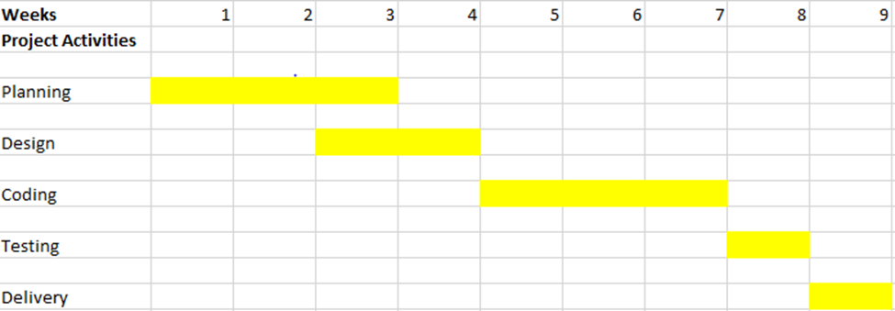

Figure 6.1 Gantt chart

# System Analysis and Design



## Introduction

In this chapter, the system analysis and design diagrams are shown. The design and implementation of the system is shown through various diagrams, which include use case diagram, sequence diagram, context level diagram ad level 0 diagram.



## Analysis Diagrams

### Use case diagram

This diagram shows the processes involved in the system. A new member is supposed to register so that he is given permission to access the services of the application. Once registered, he can log in to the system and access the services where if he/she is a lecturer, he/she is able to book a room while if a student, he/she is only allowed to view the free rooms.

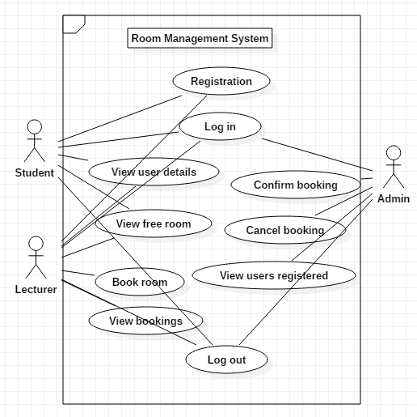

Figure 4.1 Use case

### Sequence diagram

This diagram shows the interaction between different the different lifelines in the system. It shows what happens after every step a user has taken.

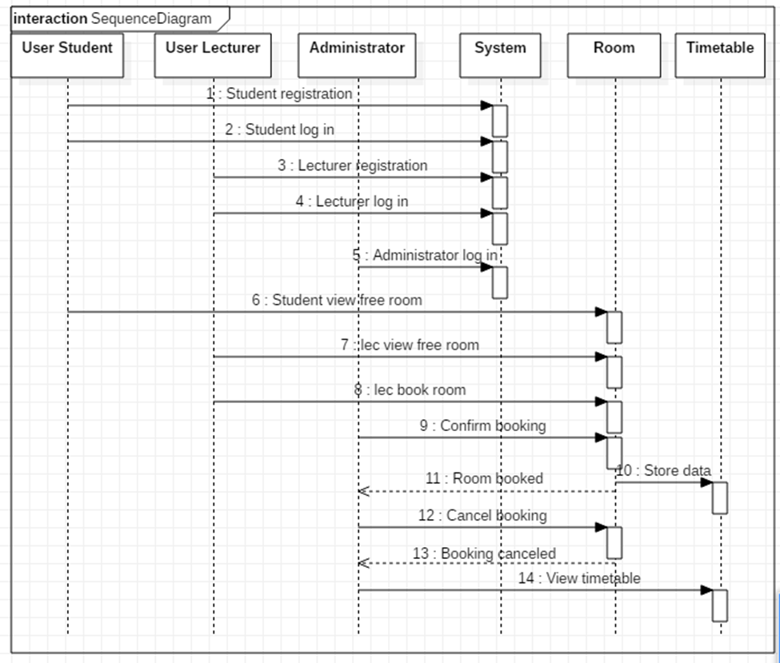

Figure . System Sequence

### Context diagram

A context diagram is a diagram that defines the boundary between the system, part of a system and its environments showing the entities that interact with it. This diagram is a high-level view of a system.

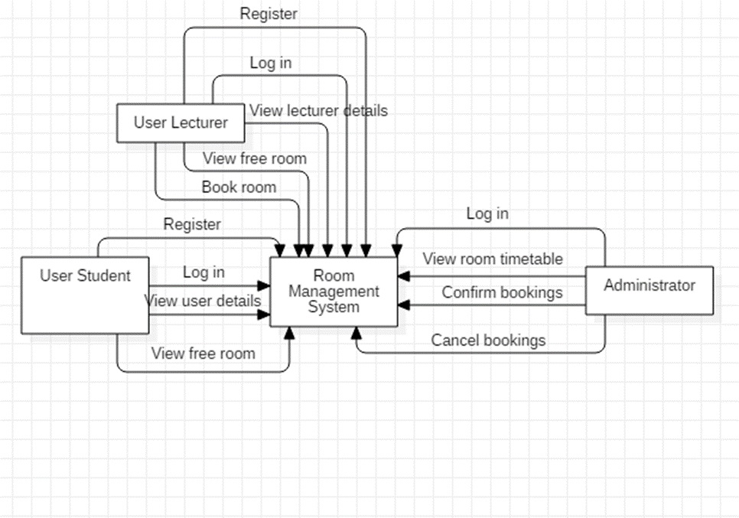

Figure . Context diagram

### Level 0 diagram

This diagram shows how data flows through the system after being inputted by the user at every stage.

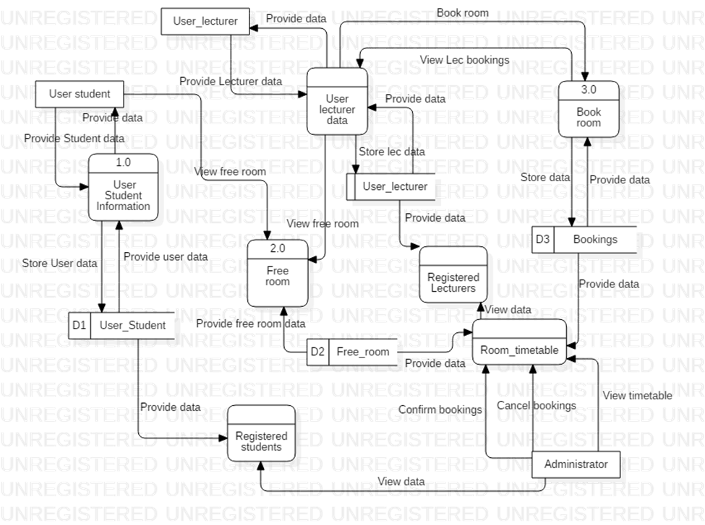

Figure . Level 0 diagram

### Entity Relationship diagram

This diagram shows the different entities that are in the system and how they are related. It also shows the different attributes of every entity.

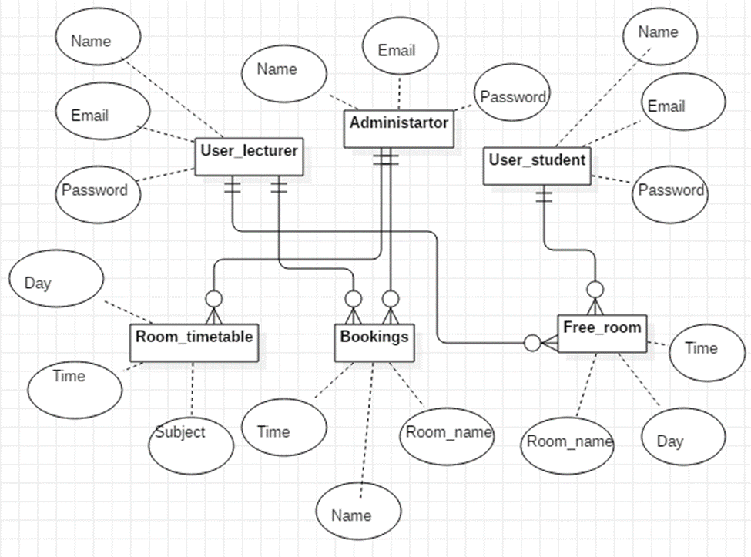

Figure . Entity Relationship diagram



### Database schema

This diagram shows where every data inputted by the user will be stored.

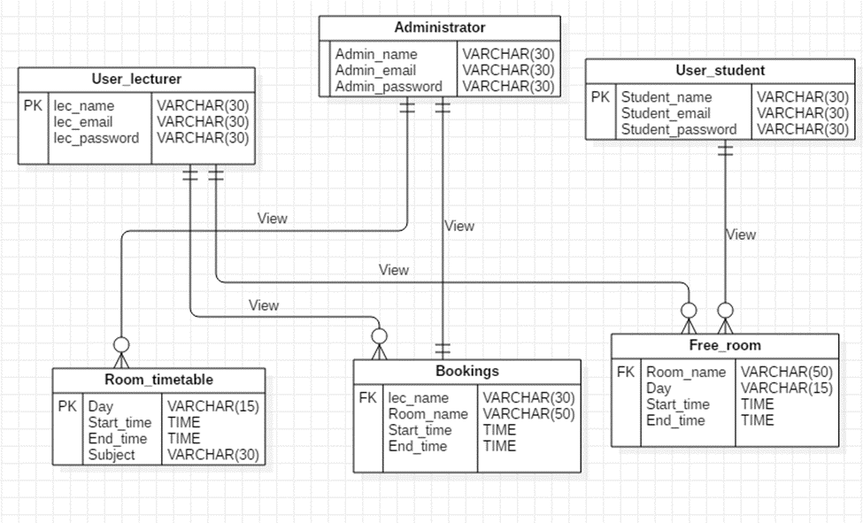

Figure . Database schema

### Flow chart

Flow chart is a type of diagram that represents an algorithm, work or process. It shows what happens in a system systematically allowing the system to follow certain procedure from one process to another.

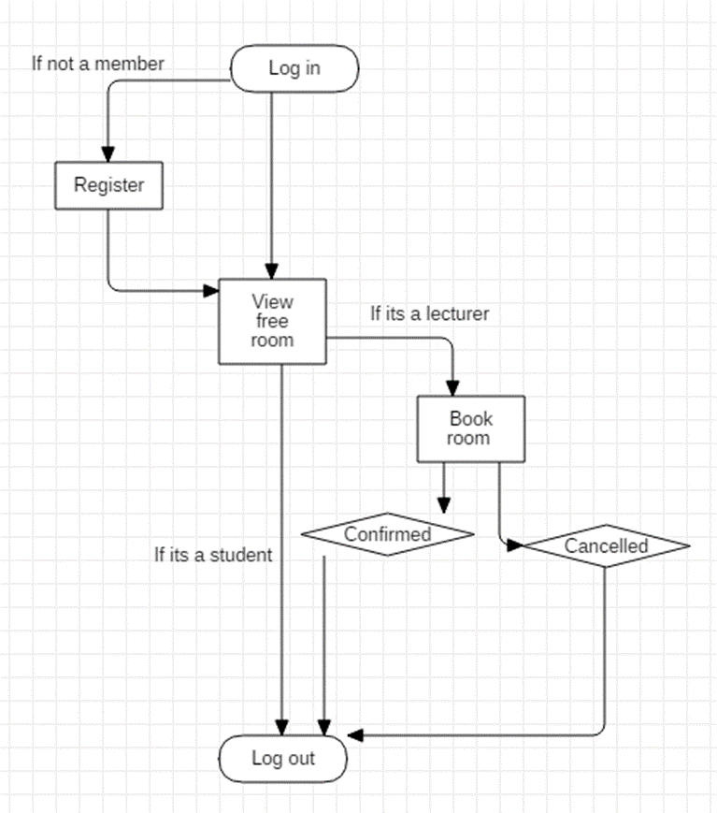

Figure . Flow chart

# System Implementation and Testing



## Introduction

This chapter is about the different modules in that are in the system. The modules include the admin module and the user module.

## Administrator module

The administrator like any other user needs to log into the system to carry out his/her activities.

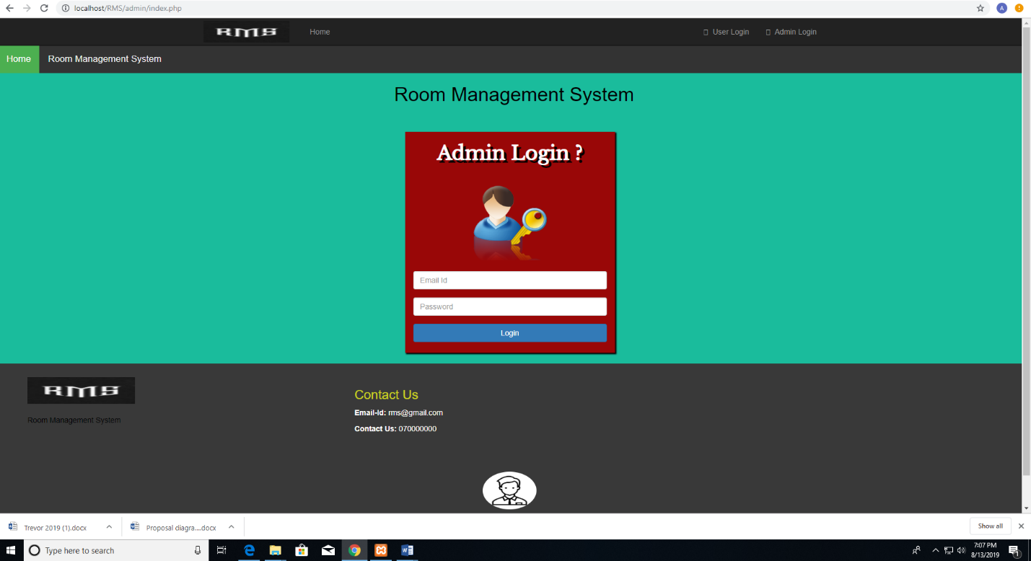

Figure . Admin log in

He is able to add new rooms into the system to accommodate the new rooms that maybe established. He is also able to delete the rooms.

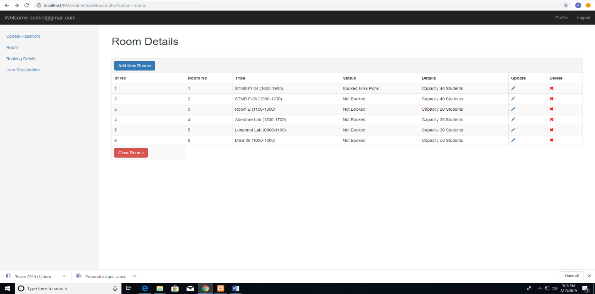

Figure . Room details

He is able to update the information in the rooms so as to notify users whether the room is booked or not.

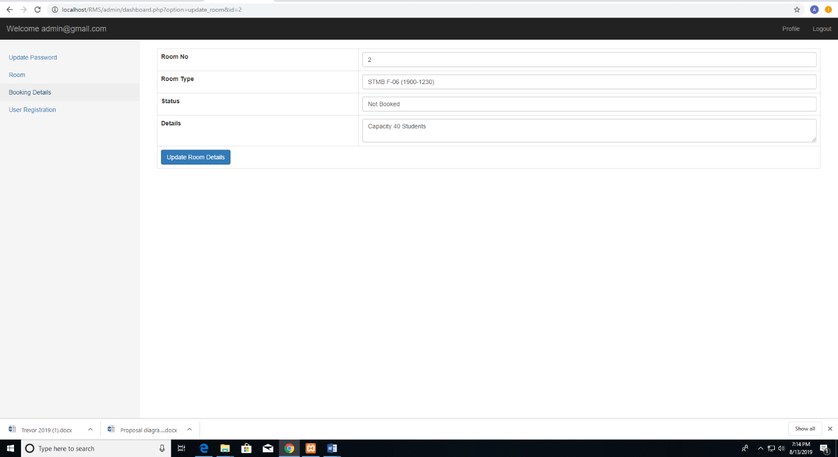

Figure . Update room details

The administrator is able to see the users that have requested to book a room so that he/she can update the information. He/she is able to cancel a booking in the case that a room was booked twice, the first user is the one who is approved.

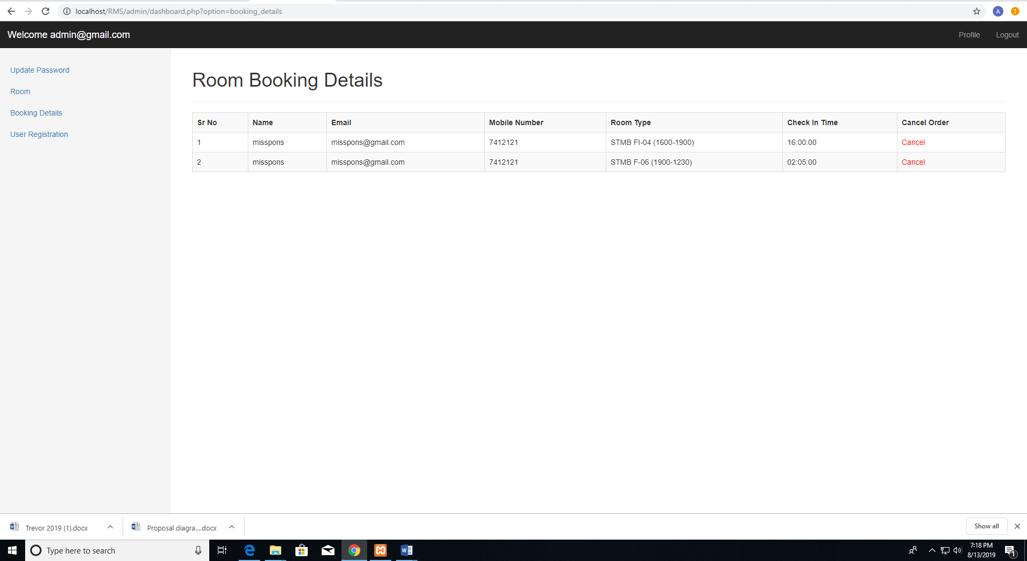

Figure . Room booking details

The administrator is also able to see the users that have registered into the system.

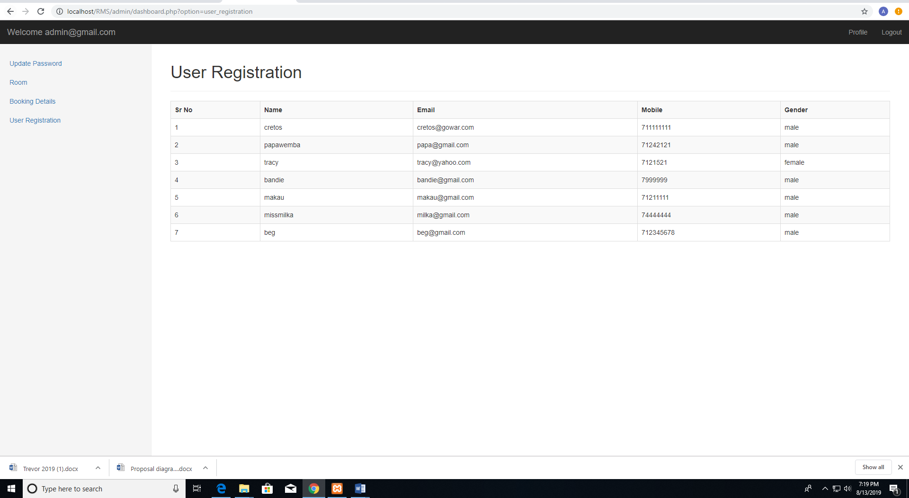

Figure . Users registered

## User module

The system has two types of users who have different functions. The lecturer is able to book rooms in the system while the student is only able to see the free rooms, which are not occupied.



### Lecturer

The lecturer is able to book a room so that he/she can have a class. An unregistered user needs to register into the system.

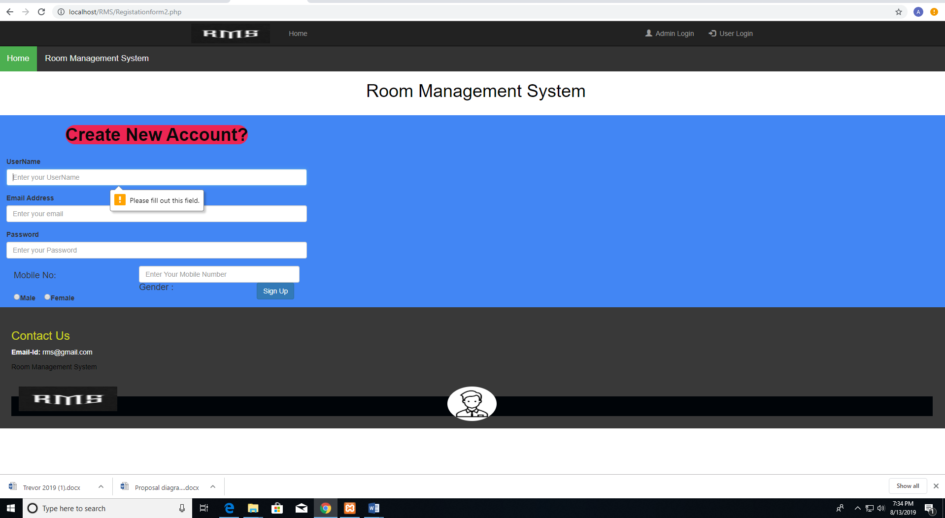

Figure . Lecturer registration

The lecturer like any other user is also required to log into the system so that when he/she books a room the administrator know who booked the room.

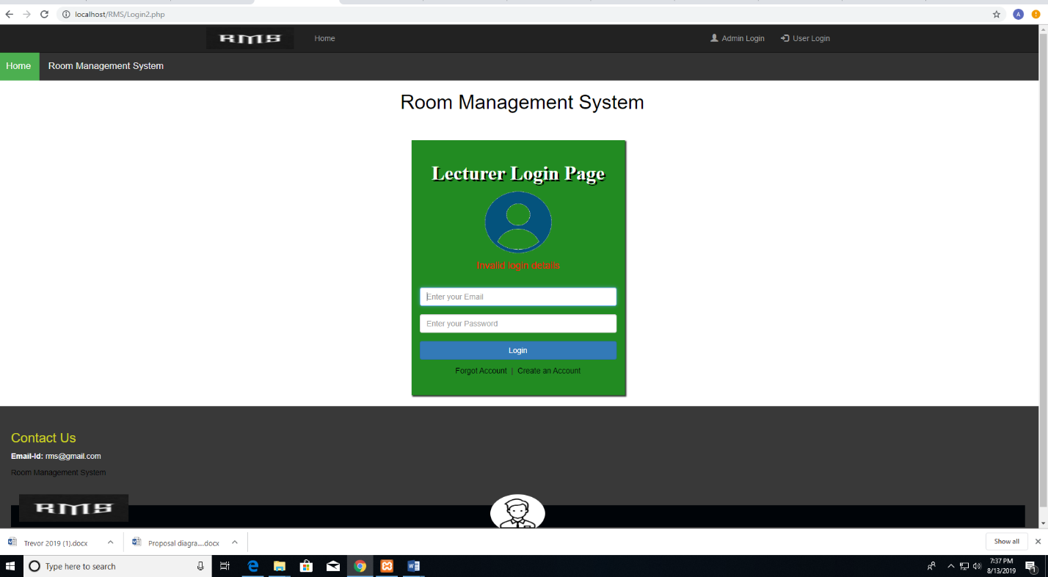

Figure . Lecturer log in

The lecturer can book rooms in the system.

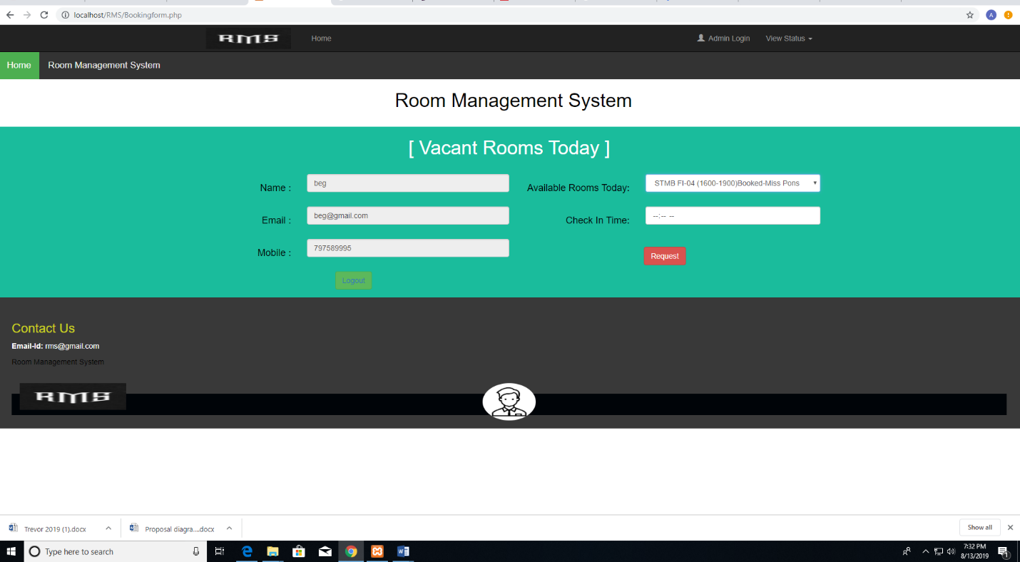

Figure . Lecturer book room

After a successful booking, he/she gets a confirmation message.

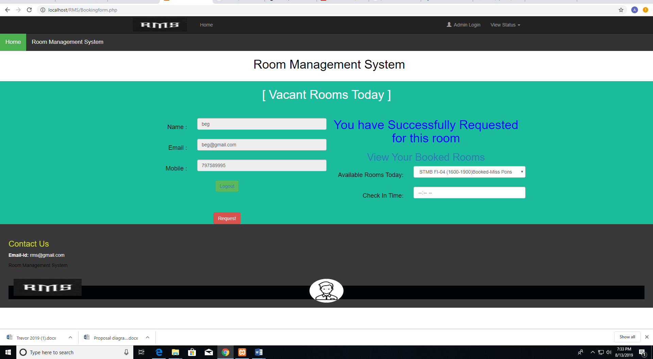

Figure . Success message

He/she can also see the rooms that he/she had already booked before.

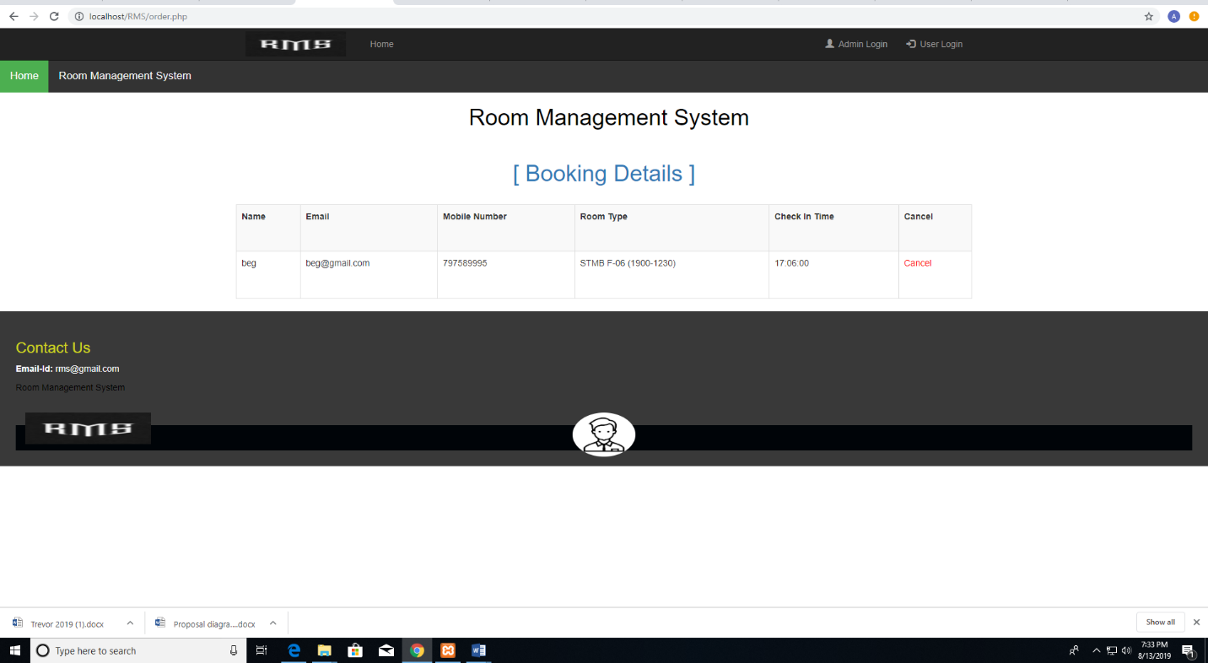

Figure 5.10 Booking history

### Student

An unregistered student needs to register into the system.

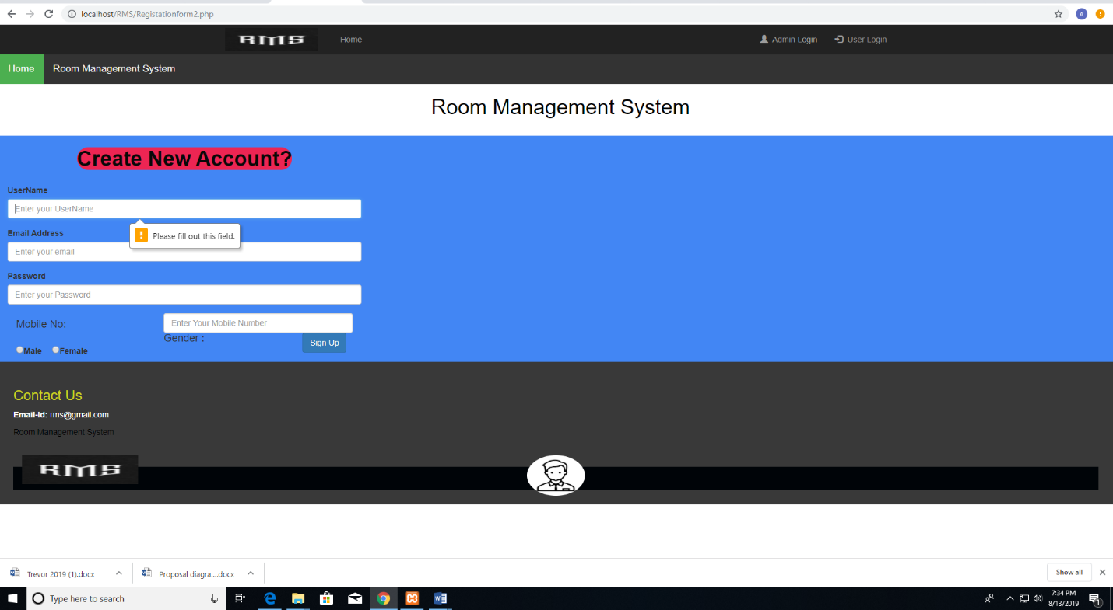

Figure . Student registration

He/she needs to log into the system to access the services of the system.

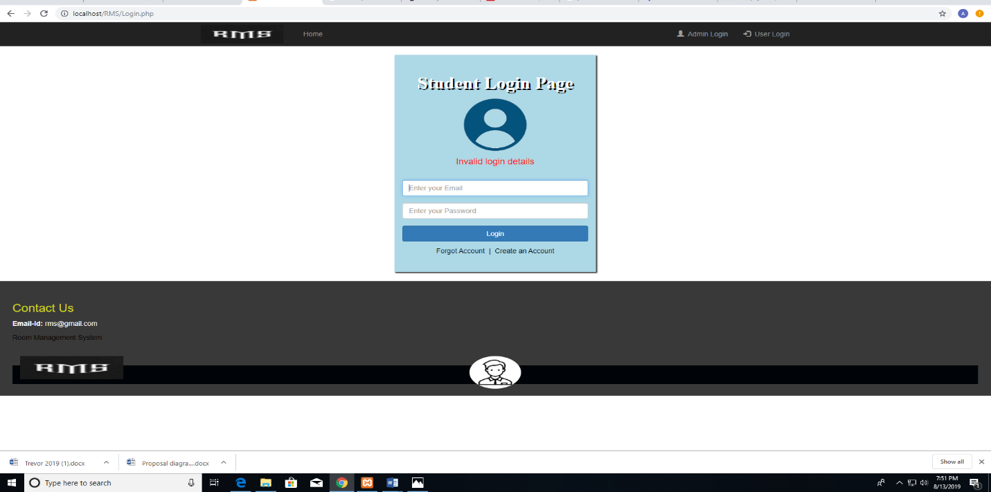

Figure . Student log in

He/she is able to see the free rooms available rooms so that he/she can go to study or have a group discussion.

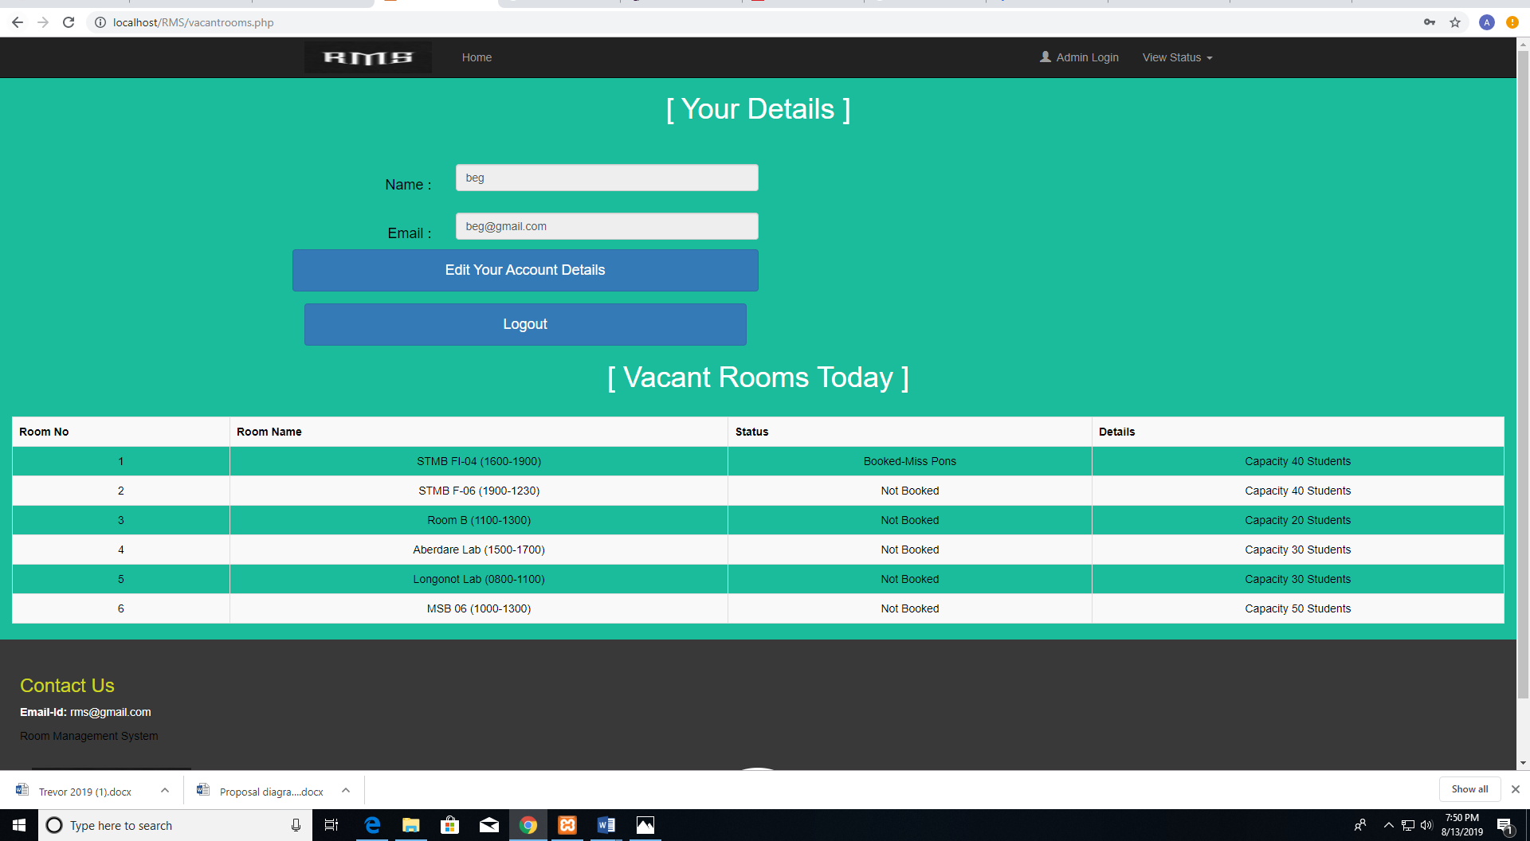

Figure . Student view free room

The student can also update his personal information.

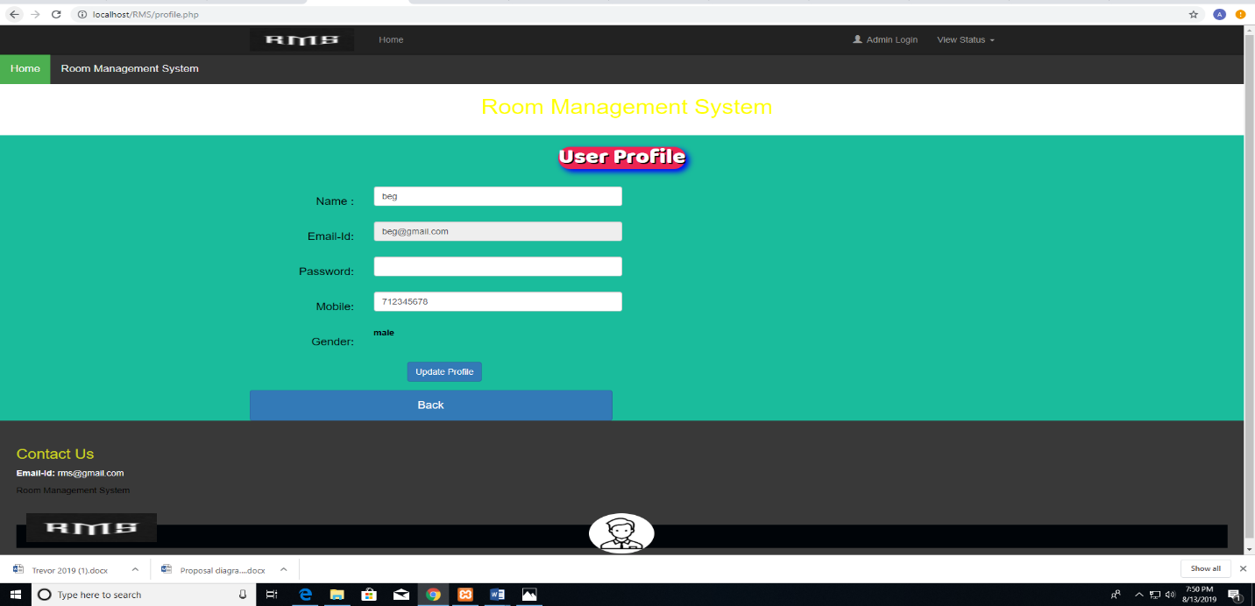

Figure . Student user profile

## System testing

This diagram shows the test that were carried out in the system and the results that were obtained.

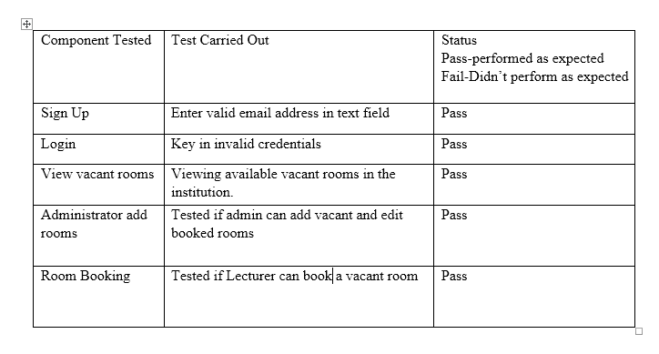

Figure . System Testing

# Conclusion, Recommendations and Future works.



## Introduction

This chapter discusses various conclusions made after the successful development of the system and the numerous recommendations that can be made with reference to the developed system. Also included in this chapter is, the anticipated future works that can be added to the developed system.

### 6.2 Conclusions

The challenges faced by students and lecturers was finding a suitable room that is not occupied so that the lecturer can organize a lesson or for the student to study. The modules in this system have tried to solve the issue. The lecturer can now book a room and have his class while the student can now search for a room very fast without moving from room to room. This system has eased the work of the lecturer and the student.

## 6.3 Recommendations

For functionality, the system requires internet connectivity to be used and a browser that can access the web application. The user should be conversant though not so much on the English language**.**

## 6.4 Future Works

The system will have a platform where students can be able to view their attendance percentages. Students will also be able to view their marks in various units that they are undergoing.

References

M, B. (2018, November 30). *KCSE Grading System 2018/2019, Subject Groups and KCSE Subject Codes*. Retrieved from Trending: https://trending.co.ke/kcse-grading-system-subject-groups-and-kcse-subject-codes/

M, C. (2015). Dynamic Room Allocation. In C. M, *Dynamic Room Allocation* (p. 77). Twente: M, Cluwen.

S, N. (2016). Classroom Booking. In N. S, *Design and Implementation of a Classroom* (p. 28). Texas: S, Navuduri.

T, M. (2000). *A Computer Based System for Space Allocation Optimisation*. Retrieved from Core: https://core.ac.uk/display/20711303